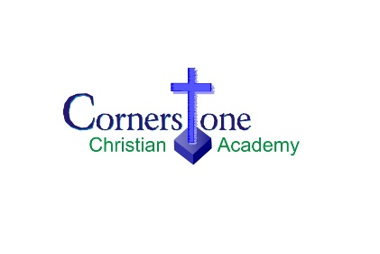**Fee Structure 2024-25**

**Kindergarten Readiness**

**Registration Fee:** $50 per child (deducted from first month’s tuition)

**Tuition**: $15 per ½ day program $30 for full day

$ 12.50 per ½ day program for CCA Families $25 for full day for CCA Families

**Grades Jk-8**

**Registration Fee**: $250 per child “Early Bird Discount” by June 30th  (existing CCA Families may postdate

this to July 31 without incurring a late fee)

$300 per child after June 30th

**Tuition Fee**: Per month for 10 months (September -June)

Select the option that best suits your situation

**Plan A:** FULL PARENTAL PARTICIPATION

Parents give 2 hours per week as a *School Assistant* during daytime hours (recess duty, washroom cleaning, teacher assistant, etc), participate in fundraising, take part in the *Parent Partnership Plan* (after school tasks such as organizing fundraisers, donor communication, etc), and assist with Sweets and Treats.

**Plan B:** PARTIAL PARENTAL PARTICIPATION

Parents give 2 hours per week as a *School Assistant* during daytime hours (recess duty, washroom cleaning, teacher assistant, etc), and assist with Sweets and Treats

**Plan C:** PARTIAL PARENTAL PARTICIPATION

Parents participate in fundraising, take part in the *Parent Partnership Plan* (after school tasks such as organizing fundraisers, donor communication, etc), and assist with Sweets and Treats.

**Plan D:** LITTLE PARENTAL PARTICIPATION

Parents assist with Sweets and Treats

**Plan A Plan B Plan C Plan D**

1 child (gr. JK-8) $618 $724 $736 $842

2 children (gr. JK-8) $722 $828 $840 $946

3+ children (gr. JK-8) $795 $901 $913 $1019

**Sponsorship**

* Existing CCA Families are requested to obtain a minimum of one *School Sponsorship* of $60/month for 12 months ($720).
* Acquiring of *School Sponsorship* is not requested from new families but appreciated.

**General Information**

* Payments are due the first of each month (Sept. 1-June 1). Alternate dates must be approved by the administration.
* Payments may be made by cash, cheque, or e-transfer.
* Families wishing to pay the entire yearly tuition by the first day of school are entitled to a 2% discount.

Families with children in grades JK-8, who used the Shopping Card Program during the 2023-24 school year, will have their tuition adjusted accordingly for the first payment of the year. Thanks for supporting this fundraiser where everyone benefits.